Foxboro Elementary Community Council
AGENDA
Tues, OCT 6, 2020, 5:30-6:30PM
via Zoom Conferencing (Meeting ID: 885 9423 9539 Passcode: 485921)
[bolded items: action items]
- Welcome and Introductions
  - Alisa Van Langeveld (Pres), Aimee Fautin (VP), Parker Huber (Sec), Lacey ?, Anita Strickland, Alyssa Butler, Chris Whitaker (Principal) , Kayla Moosman, Emily Clark, Megan Klingler, Valerie Dimas, Liana Lindeman, Patricia Tryon, Katy Porter
- Community Council Responsibilities
  - Membership
    - Chris to place names/emails/other info of new council members on list posted on school website by next meeting
  - Training Video – www.schoolLandTrust.org
    - School Land Trust Plan (School Improvement Plan)
    - School Safety Plan
    - Digital Citizenship Review
    - Consulting on Positive Behaviors Plan
  - School Website Update (by Oct 20)
    - council member names and contact information,
    - a proposed meeting schedule for the year,
    - the Rules of Order and Procedure updated for the school year,
    - and a report to parents on how the School LAND Trust program funds were used in the prior year with the amount of money the school has received from the program.
    - School Land Trust Plan (School Improvement Plan)

- School Update (teachers, enrollment, COVID protocols)
  - Update from Ms. Whitaker
    - Praised quality and hard work of teachers
      - Morale is good
      - Needs from community:
        - Hand sanitizer
        - Volunteers to assist/tutor in the classroom
          - Aimee/Emily to work together to assess teachers’ needs/desires
          - PTA involvement
            - Jodie Banks is teacher rep, could coordinate
            - Aimee to email Jodie and Emily to crowdsource ideas from faculty for the community and parents assisting teachers and/or ways volunteer in classrooms
    - New district dashboard with COVID statistics easily available
    - Children have done a good job with masks, hand washing, hand sanitizing
- School Safety / Emergency Plan
  - School Plan Overview
    - Reviewed by Mrs. Dimas
    - Valerie to ensure the plan is posted soon on the school website
  - Areas of safety – fire, earthquakes, weather or natural disasters, illness, walking/drop off plan, gun safety, physical safety
    - Bomb threats, civil unrest, hazardous materials, fallen aircraft, medical response, utility failures
- Bullying at the School
  - Review discipline procedures (Positive Behavior Plan)
    - Problem Behavior flowchart [see image at end of minutes]
    - Mrs. Whitaker presentation
      - Foxboro Elem has always tracked behavior/discipline data
      - This year, using a new program called PBIS Rewards to track
      - Tries to categorize each incident by behavior type and by location to determine problem areas and prevalent types of behavior
      - Response to bad behavior:
        - Trying to focus on reteaching correct behavior, rather than handing down consequences, which usually just lead to students trying not to get caught
          - Examples of reteaching include “Walking recesses” with administrators, apology to harmed students, performing service to the school (shoveling snow for example), etc.
      - Contacting parents timeline:
        - Injuries are immediately communicated
        - May take a day or two if investigation is needed
      - Location to report incidents:
        - Office is always open to students and they are told that. Teachers also trained to accept
      - Suggestions by parents to administrators
        - More immediacy with communications
          - Specific suggestion by Ms. Whitaker – an immediate email to all involved parents informing that an incident took place, even if an investigation will still occur
          - Email notifications of incidents could encourage parents to respond quickly if they are especially concerned or would like a specific response
        - More empathetic, understanding responses from administrators, erring on side of over-communicating/reacting, since parents may find a given situation more serious than the school
        - Better processes/workflows to streamline process of logging incidents and informing/emailing/calling all concerned parents
        - Inform parents of their action options when incidents occur
  - Prevalence – how many incidences are occurring?
- Program Updates – PTA, Meet the Masters, Summer library, Watch Dogs
  - Parker to check PY WatchDOGS signup site to see if we have an email list we could hit to encourage ad hoc volunteering this year.
- Questions and Open Topics
- Review Action Items

- Upcoming Dates and Next Meeting

  - November 10

- Adjourn

Foxboro Elementary Community Council
2020-2021 MEETING TOPICS
Date | Topics
Aug | Review Start of School plan  Review annual agenda topics
Sept | Training, Role and responsibilities of the Council  Review Goals for the PAST School Improvement Plan  Review Goals for CURRENT School Improvement Plan
Oct | Program Updates – PTA, Summer Library, Watch Dogs  School Safety, Bullying
Nov | Digital Citizenship  Social Emotional Learning  Social citizenship
Dec | Science
Jan | Math
Feb  STEM Night | STEM NIGHT – no meeting
Mar | Reading
Apr  District Planning Meeting | Review 2021-2022 Plan
May  Class of 2021/2027  Graduates Parade | Yearly review, programs review, recommendations for next year,  appoint leadership

The purpose of school community councils is to: “build consistent, effective collaboration and communication among parents, employees, and administrators; and to provide a forum to be actively involved with the school in their children’s education.”
Community Council responsibilities include:
1. Mandatory data review to identify critical academic needs.
2. Prepare and update the School Improvement Plan (School Land Trust Plan)
3. Digital Citizenship review and recommendations
4. School Safety Plan review and recommendations
5. Positive Behavior Plan review and recommendations

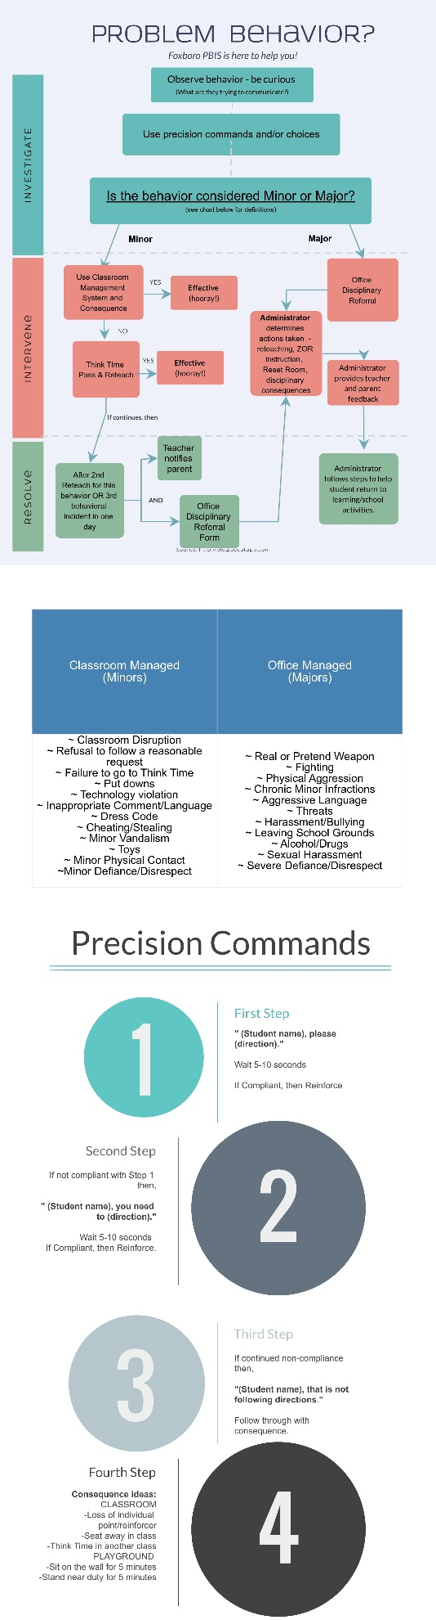
Problem Behavior Flowchart:

